ALTA Rocky Mountain Chapter: Event Proposal

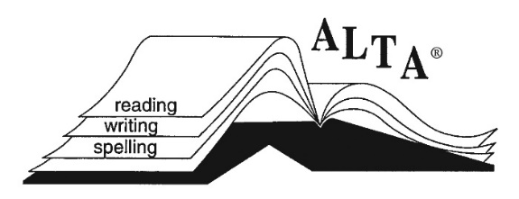

Event Information

name(s) of Sponsoring ALTA Member(s) (Must Be Current Members): __________________________________________________________________________________________________________________________________________

Title of Event: _____________________________________________________

Date of Event:______________________________________________________

Location of Event: _________________________________________________

Cost for Participants: _____________________________________________

What is your expected profit (if any)? _____________________________

How does your event support ALTA’s mission and/or vision? ____________________________________________________________________________________________________________________________________________________________________________________________________________________________________________________________________________________

ALTA’s MISSION STATEMENT
In service to our community, we build awareness in the field of dyslexia by providing professional development and community outreach through our expertise and leadership.

ALTA’s VISION Statement
We envision a community where every child learns to read and spell proficiently without hardship.

Marketing materials
If approved, please have documents or images prepared that we can share on your behalf to help market your event. We have email and Facebook channels through which to market. JPEG images tend to work best on Facebook.

This form and any questions should be emailed to altarmc.board@gmail.com. Thank you!

